1)docker 1 assignment

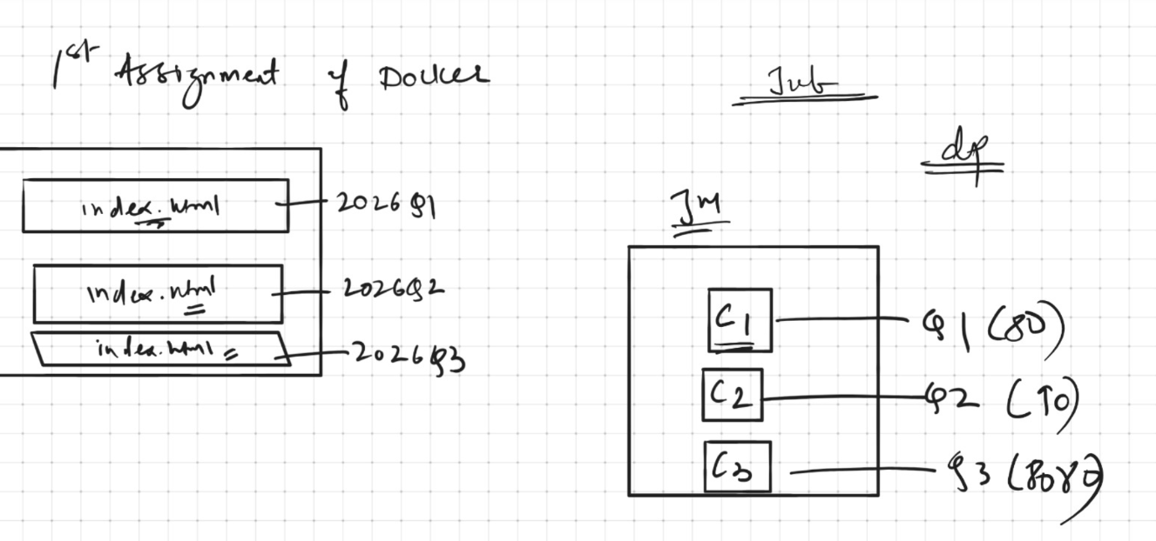

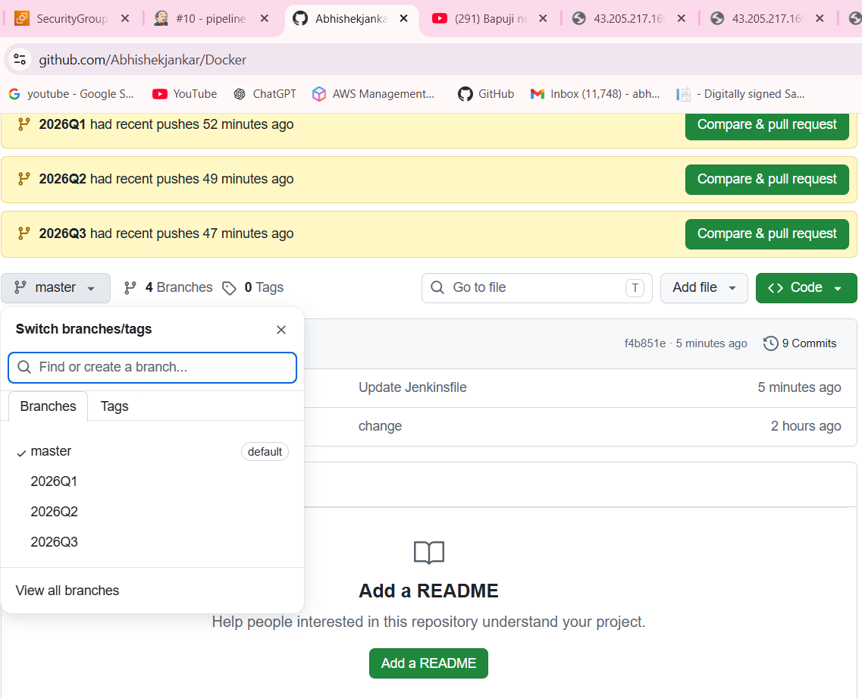
pipeline {

agent any

environment {
REPO_URL = "https://github.com/Abhishekjankar/Docker.git"
}

stages {

stage("workspace clean"){

steps {

cleanWs()
}

}

stage("clone 2026Q1"){

steps{
dir("/mnt/Q1"){
git branch: "2026Q1", url:"${REPO_URL}"

}

}
}

stage("clone 2026Q2"){

steps{
dir("/mnt/Q2"){

git branch: "2026Q2", url:"${REPO_URL}"
}

}

}

stage("clone 2026Q3"){
steps{

dir("/mnt/Q3"){

git branch: "2026Q3", url:"${REPO_URL}"
}
}
}

stage("deploy 2026Q1 on c1"){

steps{
sh'''

docker rm -f c1 || true
docker run -dp 80:80 --name c1 httpd
docker cp /mnt/Q1/index.html c1:/usr/local/apache2/htdocs/
docker exec c1 chmod -R 777 /usr/local/apache2/htdocs/index.html

'''
}
}
stage("deploy 2026Q2 on c2"){

steps{

sh'''

docker rm -f c2 || true
docker run -dp 90:80 --name c2 httpd
docker cp /mnt/Q2/index.html c2:/usr/local/apache2/htdocs/
docker exec c2 chmod -R 777 /usr/local/apache2/htdocs/index.html
'''

}

}

stage("deploy 2026Q3 on c3"){
steps{

sh'''

docker rm -f c3 || true
docker run -dp 8081:80 --name c3 httpd
docker cp /mnt/Q3/index.html c3:/usr/local/apache2/htdocs/
docker exec c3 chmod -R 777 /usr/local/apache2/htdocs/index.html
'''
}
}
}
}

2)2026Q1 deployment


2)2026Q2 deployment



3)2026Q3 deployment


